**Calendar of work**

|  |  |
| --- | --- |
| Requirements analysis | April 8th, 2019 |
| Research presentation | April 12th ,2019 |
| Gathering requirements | April 15th,2019 |
| Writing codes for the algorithms | April 16th, 2019- April 29th,2019 |
| Implementing the codes, get output for the first three algorithms before the presentation | April 30th to May 1st, 2019 |
| Final presentation | May 2nd, 2019 |
| Error rectification and final implementation of Markov prefetching. | May 3rd, 2019 |
| Project report preparation | May 8th, 2019 |
| Final submission | May 9th, 2019 |

**Division of Labor**

|  |  |
| --- | --- |
| **Members** | **Division of labor** |
| Sapthagiri Venkat Raghuraman | Requirements gathering, implementation of one algorithm |
| Sai vyshnave koduru Srinivasa | Requirements gathering, implementation of algorithms, coding of the remaining two algorithms, testing all the three algorithms and preparing the final report |
| Sourav Ranjan | Requirements gathering, implementing the Markov process, coding, and testing, checking the document.  Gem5 environment set-up, SPEC CPU-2017 Integration, Environment testing |

Proof of correctness:

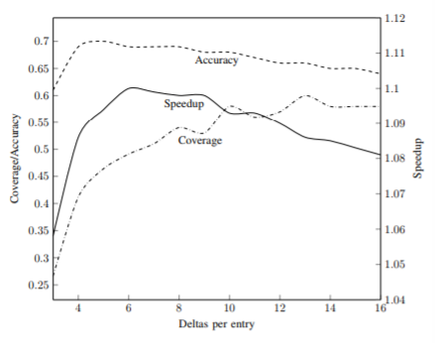

DCPT speed up, accuracy and coverage difference for the delta per entry

Let us observe the above graph for a better analysis of the results. The DCPT had the best performance when compared to any other algorithms. The proof is given in the below paragraph. We can observe from the graph that bits are used which is called the delta values. Deltas are the small address when compared to the full address. Just a few bits were used to represent the delta. We used six deltas per entry for a hundred entries. We observed that when the delta bit values when it was too small, many of the delta values got ignored and where not stored in the delta buffer due to the buffer overflow. We saw a significant increase in the speed up, coverage and accuracy when the delta values were set between nine to ten . When the delta value was set for six we observed the best speed up. The speedup decreased when the size of the delta values was set too high .when the delta value is high the distance for prefetching increases. Hence we conclude that using the high delta values will degrade the performance. The small delta values gave the best performance. When compared to all the algorithms the table size is not so big. Based on the table size the best performance is achieved. Using the delta algorithm for the larger tables gave the best results when comparing it with other algorithms.